**Name: NEHA ANTONY**

**Roll No:23**

**Batch:MCA-B**

**Date:8-04-2022**

**ADVANCED DATABASE MANAGEMENT LAB**

**Experiment No.: 2**

**Aim**

To familiarize with selecting data from single table

**QUESTION**

1. List all data from table deposite

2. List all data from borrow

3. List all data from customer

4. List all data from branch

5. Give account no and amount of deposite

6. Give customer name and account no of depositors

7. Give name of customers

8. Give name of branches

9. Give name of borrows

10. Give names of customer living in city Nagpur

11. Give names of depositors having amount greater than 4000

12. Give account date of Anil

13. Give name of all branches located in Bombay

14. Give name of borrower having loan number l205

15. Give names of depositors having account at VRCE

16. Give names of all branched located in city Delhi

17. Give name of the customers who opened account date ‘1-12-96’

18. Give account no and deposit amount of customers having account opened between dates ‘1-12-96’ and ‘1-5-96’

19. Give name of the city where branch KAROLBAGH is located

20. Give details of customer ANIL

**PROCEDURE**

1. SELECT * FROM myaccount.deposit;

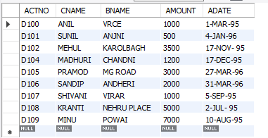

2. SELECT * FROM myaccount.borrow;

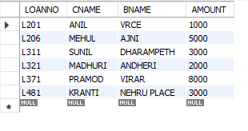

3. SELECT * FROM myaccount.customer;

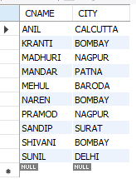

4. SELECT * FROM myaccount.branch;

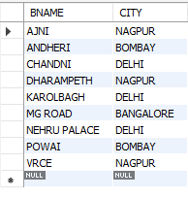

5. select ACTNO,AMOUNT from myaccount.deposit;

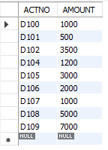

6. select CNAME ,ACTNO from myaccount.deposit;

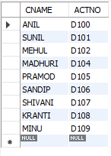

7. select CNAME from myaccount.customer;

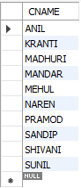

8. select BNAME from myaccount.branch;

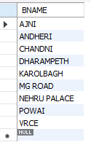

9. select BNAME from myaccount.borrow;

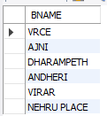

10. select CNAME from myaccount.customer where city="Nagpur";

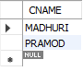

11. SELECT CNAME from myaccount.deposit where AMOUNT>4000;

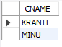

12. SELECT ADATE FROM myaccount.deposit where CNAME='ANIL';



13. SELECT BNAME from myaccount.branch where CITY='Bombay';

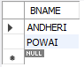

14. select BNAME from myaccount.borrow where LOANNO='L1205';



15. SELECT CNAME from myaccount.deposit WHERE BNAME='VRCE';



16. SELECT BNAME from myaccount.branch WHERE CITY='Delhi';

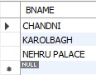

17. SELECT CNAME from myaccount.deposit WHERE ADATE='1-Mar-96';



18. SELECT ACTNO,AMOUNT from myaccount.deposit WHERE ADATE BETWEEN '1-Dec-96' AND '1-May-96';

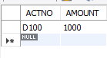

19. SELECT CITY from myaccount.branch WHERE BNAME='KAROLBAGH';



20. SELECT * from myaccount.customer join borrow on customer.cname=borrow.cname join deposit on deposit.cname=borrow.cname WHERE customer.cname='ANIL';

